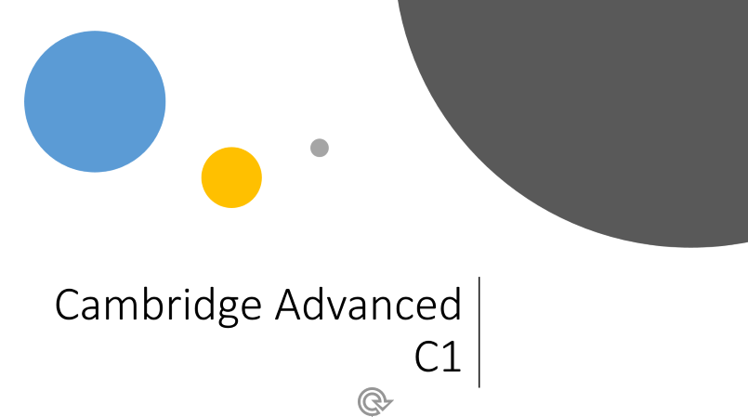

What is it?

It is a certificate that proves your proficiency (skill) in the English language.

-C1 refers to the European Framework of Reference for Languages. This framework is used for the grading of an individual’s language proficiency. There are 6 levels (A1, A2, B1, B2, **C1**, C2). A1=lowest, C2=highest.

-You pass the exam with a score grade A, B or C.

Just to compare:

-Cambridge First Certificate = B2

-Regular English 6VWO = B2 Writing/Speaking, C1 Listening/Reading

1

